**PG-DAC AUGUST 24 BATCH**

1)Write a Java program that takes a list of integers as input and returns a list of duplicate integers.

import java.lang.invoke.ConstantBootstraps;  
import java.util.*;  
  
public class Q1 {  
 public static List<Integer> getList(){  
 Scanner sc = new Scanner(System.*in*);  
 System.*out*.println("No. of Elements: ");  
 int size = sc.nextInt();  
 List<Integer> list = new ArrayList<>(size);  
  
 for (int i = 0; i < size; i++) {  
 System.*out*.println("Enter "+i+" Element: ");  
 list.add(i, sc.nextInt());  
 }  
 return list;  
 }  
 public static void main(String[] args) {  
 List<Integer> list = *getList*();  
 List<Integer> Ans = new ArrayList<>();  
 Collections.*sort*(list);  
  
 System.*out*.println("List: ");  
  
 System.*out*.println(list);  
  
 for (int i = 0; i < list.size()-1; i++) {  
 if (list.get(i) == list.get(i+1) && !Ans.contains(i)){  
 Ans.add(list.get(i));  
 }  
 }  
 System.*out*.println("Repeated Elements "+Ans);  
  
  
 }  
}

Output:

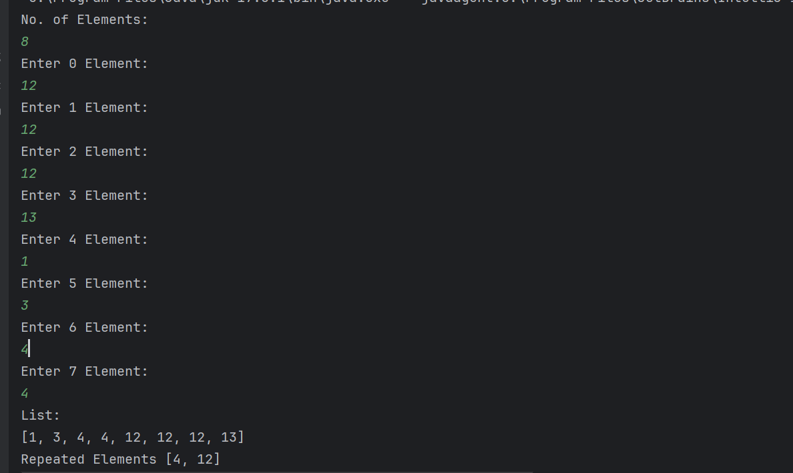

2)Create a Person class with attributes name and age. Write a Java program that sorts a list of Person objects first by age and then by name if the ages are equal.

import java.util.*;  
  
class SortByName implements Comparator<Person>{  
 @Override  
 public int compare(Person p1 , Person p2){  
 return p1.Name.compareTo(p2.Name);  
 }  
}  
class SortByAge implements Comparator<Person> {  
  
 @Override  
 public int compare(Person o1, Person o2) {  
 return o1.Age - o2.Age;  
 }  
}  
class Person {  
 String Name;  
 int Age;  
  
 Person(String Name, int Age){  
 this.Name = Name;  
 this.Age = Age;  
 }  
  
}  
  
public class Q2 {  
 public static void print(List<Person> list){  
 for (Person ele: list ) {  
 String formatted = String.*format*("%-12s%d", ele.Name, ele.Age);  
 System.*out*.println(formatted);  
 }  
 }  
  
 public static void main(String[] args) {  
 List<Person> set = new ArrayList<>();  
 Person p1 = new Person("Atharva",22);  
 Person p2 = new Person("Amey",16);  
 Person p3 = new Person("Sahil",23);  
 Person p4 = new Person("Ojas",15);  
  
 set.add(p1);  
 set.add(p2);  
 set.add(p3);  
 set.add(p4);  
  
// print(set);  
 System.*out*.println("Sort By Age : ");  
 Collections.*sort*(set,new SortByAge());  
 *print*(set);  
 System.*out*.println();  
 System.*out*.println("Sort By Name : ");  
 Collections.*sort*(set,new SortByName());  
 *print*(set);  
  
 }  
}

Output:

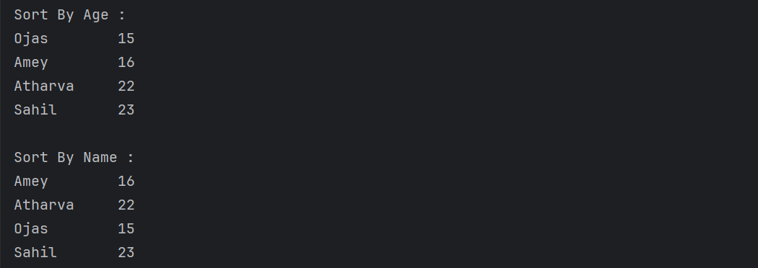

3)Write a Java program to find the first non-repeated character in a string using a HashMap.

String input = "aabbccddeffg";

Expected output = 'e';

import java.util.HashMap;  
  
public class Q3 {  
 public static void main(String[] args) {  
 String str = "aabbccddeffg";  
 HashMap<Character,Integer> map = new HashMap<>();  
  
 for (int i = 0; i < str.length(); i++) {  
 char ch = str.charAt(i);  
 if (map.containsKey(ch)){  
 map.put(ch, map.get(ch)+1);  
 }else{  
 map.put(ch,1);  
 }  
 }  
  
 System.*out*.println("Unique Elements: ");  
 for (char c: map.keySet()) {  
 if (map.get(c) == 1){  
 System.*out*.print(c +" ");  
 }  
 }  
 }  
}

Output:



4) Write a Java program that merges two sorted lists of integers into a single sorted list.

import java.util.ArrayList;  
import java.util.List;  
  
public class Q4 {  
 public static void main(String[] args) {  
 List<Integer> merged = new ArrayList<>();  
  
 List<Integer> l1 = new ArrayList<>();  
 l1.add(10);  
 l1.add(30);  
 l1.add(50);  
 l1.add(80);  
 l1.add(90);  
 l1.add(100);  
  
 List<Integer> l2 = new ArrayList<>();  
 l2.add(20);  
 l2.add(40);  
 l2.add(60);  
 l2.add(70);  
  
 int i = 0;  
 int j = 0;  
  
 while (i < l1.size() && j < l2.size()){  
 if (l1.get(i) < l2.get(j)){  
 merged.add(l1.get(i));  
 i++;  
 }else{  
 merged.add(l2.get(j));  
 j++;  
 }  
 }  
 while (i < l1.size()){  
 merged.add(l1.get(i));  
 i++;  
 }  
 while (j < l2.size()){  
 merged.add(l2.get(j));  
 j++;  
 }  
  
 System.*out*.println(merged);  
 }  
}

Output:

